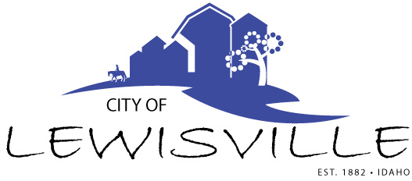
P.O. Box 160, Lewisville, Idaho 83431 · 208.754.4355

Lewisville City Council
Special Work Meeting
Notice and Agenda

Notice is hereby given of a Special Work Meeting of the Lewisville City Council to be held:

Monday, July 22, 2020 at 7:00 p.m.
Lewisville Community Center, 3451 E 480 N, Lewisville, Idaho
and via Zoom

with the following Agenda:

Agenda
Roll Call: George h Linda H James H Brigham H Mark H

- Planning and preparation of budget for FY 2021 anticipated revenue and anticipated expenditures. Proposed Budget to be presented to the public at the Budget Hearing on August 12, 2020 at 7:00 p.m. – Action Item
- John and Joe Jardine – Building Permit and property division. Action Item.

Adjournment: Action Item

Due to the social distancing recommendations set forth by Gov. Little, and in accordance with the Governor’s Proclamation, anyone wishing to attend this meeting via zoom may do so by calling the City Clerk, Donetta Fife, at (208) 390-0829 between 6:45 p.m. and 7:55 p.m. on the said date, being July 22, 2020.

Public is welcome. Any person needing special accommodations to participate in the meeting should contact City Clerk Donetta Fife at (208) 390-0829 at least 8 hours prior to the meeting.

