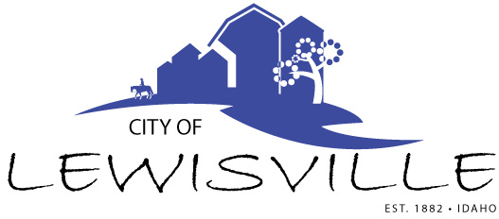
P.O. Box 160, Lewisville, Idaho 83431 · 208.754.4355

Lewisville City Council
Special Work Meeting
Notice and Agenda

Notice is hereby given of a Special Work Meeting of the Lewisville City Council to be held:

Monday, July 13, 2020 at 12:00 noon
Lewisville Community Center, 3451 E 480 N, Lewisville, Idaho
and via Zoom

with the following Agenda:

Agenda
Roll Call: George h Linda H James H Brigham H Mark H

- Discussion and adoption of local broadband plan – Action Item

Adjournment: Action Item

Due to the social distancing recommendations set forth by Gov. Little, and in accordance with the Governor’s Proclamation, anyone wishing to attend this meeting via zoom may do so by calling the City Clerk, Donetta Fife, at (208) 390-0829 between 11:45 a.m. and 11:55 a.m. on the said date, being July 13, 2020.

Any person needing special accommodations to participate in the meeting should contact City Clerk Donetta Fife at (208) 390-0829 at least 8 hours prior to the meeting.

