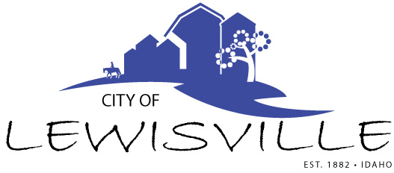
P.O. Box 160, Lewisville, Idaho 83431 · 208.390.0829

Lewisville City Council
Special Work Meeting
Notice and Agenda

Notice is hereby given of a Special Work Meeting of the Lewisville City Council to be held:

Wednesday, July 28, 2021 at 7:00 p.m.
Lewisville Community Center, 3451 E 480 N, Lewisville, Idaho

with the following Agenda:

Agenda
Roll Call: George Linda James Brigham Mark

- Budget Prep for FY 2022 – Action Item
- Amended Budget for FY 2021 – Action Item
- FY 2021-2022 Fee Schedule – Action Item
- Countryside Meadows Annexation – Action Item

Adjournment: Action Item

Any person needing special accommodations to participate in the meeting should contact City Clerk Donetta Fife at (208) 390-0829 at least 8 hours prior to the meeting.

