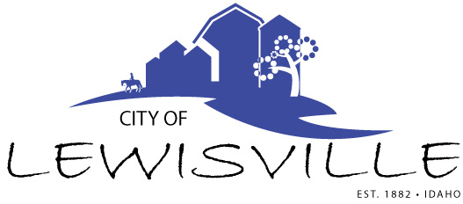
P.O. Box 160, Lewisville, Idaho 83431 · 208.390.0829

Lewisville City Council
Special Work Meeting
Notice and Agenda

Notice is hereby given of a Special Work Meeting of the Lewisville City Council to be held:

Monday, February 8, 2021 at 7:00 p.m.
Lewisville Community Center, 3451 E 480 N, Lewisville, Idaho
and via Zoom

with the following Agenda:

Agenda
Roll Call: George Linda James Brigham Mark

- Evaluation of Engineering Proposals for Wastewater Improvement Project – Action Item

Adjournment: Action Item

Social distancing recommendations will be observed. Zoom Meeting #857 5881 3038 Passcode 12345 or check the City of Lewisville website: cityoflewisville.org for a direct link. If you have questions, call City Clerk, Donetta Fife, at (208) 390-0829 at least 10 minutes before the meeting starts.

Any person needing special accommodations to participate in the meeting should contact City Clerk Donetta Fife at (208) 390-0829 at least 8 hours prior to the meeting.

