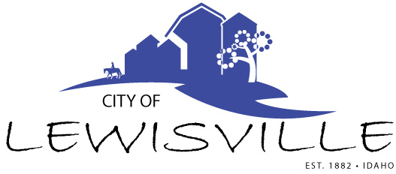
P.O. Box 160, Lewisville, Idaho 83431 · 208.390.0829

Lewisville City Council
Special Work Meeting
Notice and Agenda

Notice is hereby given of a Special Work Meeting of the Lewisville City Council to be held:

Friday, August 11, 2023 at 12:00 p.m. (noon)
Lewisville Community Center 3451 E 480 North, Lewisville, Idaho

with the following Agenda:

Agenda

Roll Call: Curtis James Brigham Celena Blake

- Application and engineering development proposal for grant for highway improvement to improve 500 North through ITD – Action Item
- Ferreter Solar Permit – Action Item

Adjournment: Action Item
Any person needing special accommodations to participate in the meeting should contact City Clerk Donetta Fife at (208) 684-2043 at least 8 hours prior to the meeting.

