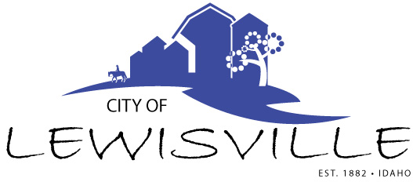
P.O. Box 160, Lewisville, Idaho 83431 · 208.684-2043

Lewisville City Council
Special Work Meeting
Notice and Agenda

Notice is hereby given of a Special Work Meeting of the Lewisville City Council to be held:

Thursday, April 16, 2026 at 7:30 p.m.
Lewisville Community Center 3451 E 480 North, Lewisville, Idaho

With the following Agenda:

Agenda

Roll Call: Fred Waco Brigham Celena Blake

- Door to Door Sales Ordinance– Action Item
- Assign Monthly Community Center Checks

Adjournment: Action Item

Any person needing special accommodations to participate in the meeting should contact City Clerk Connie Olsen at (208) 684-2043 at least 8 hours prior to the meeting.

