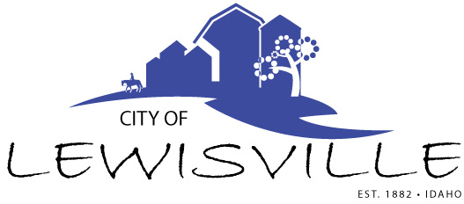

P.O. Box 160, Lewisville, Idaho 83431 · 208.684-2043

­

**Lewisville City Council**

**Special Work Meeting**

**Notice and Amended Agenda**

Notice is hereby given of a Special Work Meeting of the Lewisville City Council to be held:

**Wednesday, Aug 20, 2025 at 7:00 p.m.**

Lewisville Community Center 3451 E 480 North, Lewisville, Idaho

With the following Agenda:

**Agenda**

**Roll Call: Curtis Waco Brigham Celena Blake**

* Budget Workshop for Amendments FY 2025 Budget - Action Item
* Sidewalks – Action Item
* Set maintenance schedule for pot holes, spraying insects and weeds and mowing – Action Item
* Devan planning and zoning
* Adjournment - Action Item

Any person needing special accommodations to participate in the meeting should contact City Clerk Connie Olsen at (208) 684-2043 at least 8 hours prior to the meeting.