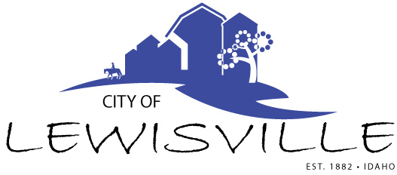
P.O. Box 160, Lewisville, Idaho 83431 · 208.390.0829

Special Lewisville City Council
Budget Hearing
Notice and Agenda

Notice is hereby given of a Special City Council Meeting and Budget Hearing for FY 2022-2023 to be held:

Wednesday, August 17, 2022 at 7:00 p.m.
Lewisville Community Center, 3451 E 480 N, Lewisville, Idaho

with the following Agenda:
Agenda
Roll Call: Curtis James Brigham Celena Blake

PUBLIC HEARING ON FY 2023 BUDGET:
- Mayor opens hearing
- Presentation of proposed FY 2023 Budget by Clerk
- Mayor takes public input, pro, neutral, negative
- Close of hearing – Action Item
- Presentation of Ordinance 2022-2 – the Annual Appropriations Ordinance for the City of Lewisville setting the budget for FY 2022-2023 – Action Item

ANNUAL FEE SCHEDULE FOR THE CITY OF LEWISVILLE FOR FY 2023:
- Presentation of Resolution 2022-1 a resolution adopting the Fee Schedule for the City of Lewisville for FY 2022-2023 – Action Item

Adjournment: Action Item

Any person needing special accommodations to participate in the meeting should contact City Clerk Donetta Fife at (208) 390-0829 at least 8 hours prior to the meeting.

