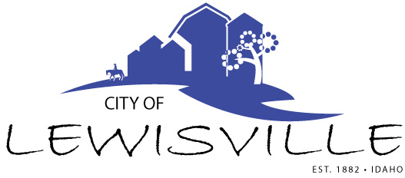
P.O. Box 160, Lewisville, Idaho 83431 · 208.390.0829

Lewisville City Council
Work Meeting
Notice and Agenda

Notice is hereby given of a Work Meeting of the Lewisville City Council to be held:

Tuesday, May 16, 2023 at 6:00 p.m.
3496 E 465 N, Lewisville, Idaho

with the following Agenda:

Agenda

Roll Call: Curtis James Brigham Celena Blake

- Mark Fletcher – building permit – Action Item
- Pedestrian – Child Safety Grant
- Development Agreement
- Code Revisions

Adjournment: Action Item

Any person needing special accommodations to participate in the meeting should contact City Clerk Donetta Fife at (208) 684-92043 at least 8 hours prior to the meeting.

