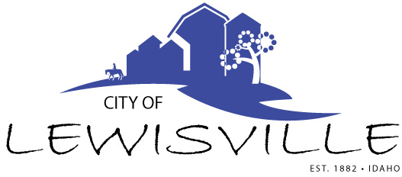
P.O. Box 160, Lewisville, Idaho 83431 · 208.390.0829

Lewisville City Council
Special Work Meeting
Notice and Agenda

Notice is hereby given of a Special Work Meeting of the Lewisville City Council to be held:

Tuesday, August 3, 2022 at 7:00 p.m.
Lewisville Community Center 3451 E 480 North, Lewisville, Idaho

with the following Agenda:

Agenda

Roll Call: Curtis James Brigham Celena Blake

- Feedback on Keller & Associates Transportation Plan – Action Item
- FY 2023 Proposed Budget – Action Item
- FY 2023 City of Lewisville Fee Schedule – Action Item

Adjournment: Action Item

Any person needing special accommodations to participate in the meeting should contact City Clerk Donetta Fife at (208) 390-0829 at least 8 hours prior to the meeting.

