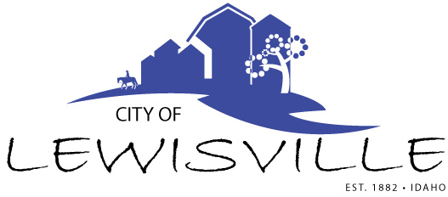
P.O. Box 160, Lewisville, Idaho 83431 · 208.390.0829

Lewisville City Council
Work Meeting
Notice and Agenda

Notice is hereby given of a Work Meeting of the Lewisville City Council to be held:

Wednesday, October 5, 2022 at 5:30 p.m.
210 Courthouse Way, Suite 170, Rigby Idaho

with the following Agenda:

Agenda

Roll Call: Curtis James Brigham Celena Blake

- Discussion with Milt Olerton – City of Lewisville, Jefferson County Impact Area Agreement.

Adjournment: Action Item

Any person needing special accommodations to participate in the meeting should contact City Clerk Donetta Fife at (208) 390-0829 at least 8 hours prior to the meeting.

