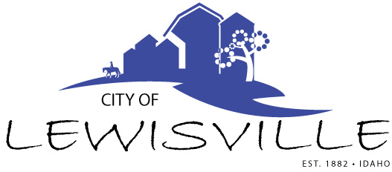
P.O. Box 160, Lewisville, Idaho 83431 · 208.390.0829

Lewisville City Council
Work Meeting
Notice and Agenda

Notice is hereby given of a Work Meeting of the Lewisville City Council to be held:

Thursday, November 3, 2022 at 7:00 p.m.
3451 E 480 N, Lewisville, Idaho

with the following Agenda:

Agenda

Roll Call: Curtis James Brigham Celena Blake

- Area of Impact with Jefferson County – Exhibit C

Adjournment: Action Item

Any person needing special accommodations to participate in the meeting should contact City Clerk Donetta Fife at (208) 390-0829 at least 8 hours prior to the meeting.

