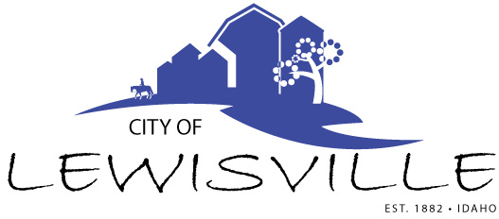
P.O. Box 160, Lewisville, Idaho 83431 · 208.390.0829

Special Lewisville City Council
Meeting and Work Meeting
Notice and Agenda

Notice is hereby given of a Special Work Meeting of the Lewisville City Council to be held:

Thursday, February 17, 2022 at 7:00 p.m.
Lewisville Community Center, 3451 E 480 N, Lewisville, Idaho

with the following Agenda:

Agenda
Roll Call: Curtis James Brigham Celena Linda

- Area of Impact Agreement with Jefferson County
- ARPA funds
- BCID Foundation Community Project

Adjournment: Action Item

Any person needing special accommodations to participate in the meeting should contact City Clerk Donetta Fife at (208) 390-0829 at least 8 hours prior to the meeting.

