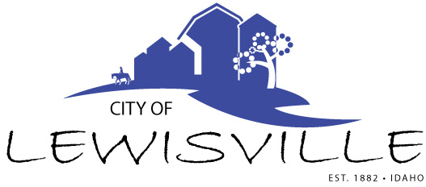
P.O. Box 160, Lewisville, Idaho 83431 · 208.390.0829

Lewisville City Council
Work Meeting
Notice and Agenda

Notice is hereby given of a Work Meeting of the Lewisville City Council to be held:

Wednesday, September 27, 2023 at 7:00 p.m.
3496 E 465 N, Lewisville, Idaho

with the following Agenda:

Agenda

Roll Call: Curtis H James H Brigham H Celena h Blake H

- Discuss Final draft of Wastewater Study done by Keller & Associates
- Discuss final draft of Traffic Study done by Keller & Associates

Adjournment: Action Item

Any person needing special accommodations to participate in the meeting should contact City Clerk Donetta Fife at (208) 684-92043 at least 8 hours prior to the meeting.

