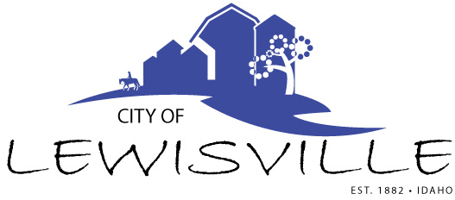
P.O. Box 160, Lewisville, Idaho 83431 · 208.390.0829

Lewisville City Council
Special Work Meeting
Notice and Agenda

Notice is hereby given of a Special Work Meeting of the Lewisville City Council to be held:

Tuesday, November 2, 2021 at 4:00 p.m.
Commissioners Room in the Courthouse Annex
210 Courthouse Way, Suite 240, Rigby, Idaho

with the following Agenda:

Agenda
Roll Call: George Linda James Brigham Mark

- Ideas on Area of Impact Agreement with Jefferson County Planning and Zoning

Adjournment: Action Item

Any person needing special accommodations to participate in the meeting should contact City Clerk Donetta Fife at (208) 390-0829 at least 8 hours prior to the meeting.

