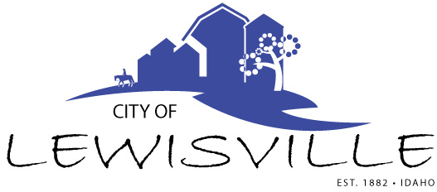
P.O. Box 160, Lewisville, Idaho 83431 · 208.390.0829

Lewisville City Council
Work Meeting
Notice and Agenda

Notice is hereby given of a Work Meeting of the Lewisville City Council to be held:

Wednesday, April 24, 2024 at 6:15 p.m.
3496 E 465 N, Lewisville, Idaho

with the following Agenda:

Agenda

Roll Call: Curtis Waco Brigham Celena Blake

- Public Right of Way Construction – additions to Lewisville Code Chapter 5 Public Right-of-way Contractors and Chapter 7 Public Right of Way Construction
- Right of Way License for Contractors
- Other

Adjournment: Action Item

Any person needing special accommodations to participate in the meeting should contact City Clerk Donetta Fife at (208) 684-92043 at least 8 hours prior to the meeting.

